25. Using Shell Programming

- Read a number and find its square
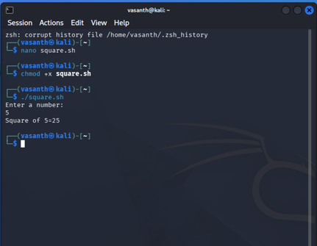

- Find the biggest of three numbers

